Business Monitoring Software

**Akshay Jadhav1, Isha Naik2, Prerana Tirodkar3**

Student, Information Technology, Fr.C.R.C.E, Mumbai, India 1

Student, Information Technology, Fr.C.R.C.E, Mumbai, India 2

Student, Information Technology, Fr.C.R.C.E, Mumbai, India 3

Abstract: In today’s fiercely competitive education segment the need for better interaction between the organisation and students (customers) and that for "should feel" feeling about being associated with the community and learn faster is growing day by day. An Enterprise resource planning system is a fully integrated business management system covering func-tional areas of an enterprise like Logistics, Production,

Finance, Accounting and Human Resources. It organizes and integrates operation processes and information flows to make optimum use of resources such as men, material, money and machine. In simple words, En-terprise resource planning promises one database, one application, and one user interface for the entire enterprise, where once disparate systems ruled manufacturing, distribution,finance and sales. Thus easing work for the management as well as the employees, improv-ing information availability and

transparency.Helping the management track operations

and cash flow, also meet primary goals of the organisation that of giving the students good experience by reducing the internal organisational confusion and availing smooth functioning of the system. Departmental information acts as a fundamental tool that assists employees and managers

plan, monitor and control the entire business,centralize information and ease functioning. The Business Monitoring Software (BMS) is a con-coction of all the essential entities to ensure hassle free functioning of the organization. Business monitoring software is influenced by a large number of factors and operational hurdles faced by the educational organization. It intends to abolish the man power and energy involved in the business operations carried out by the members involved. Thus ERP solution seek to streamline and integrate operation processes and information flows in the company to synergies the resources of organisation namely men, material, money and machine through information.

Keywords: ERP, Research &Development, Human

1. **Introduction**

An ERP -Enterprise Resource Planning system is a centralised software system that pro-cesses institution-wide transactions such as sales, marketing, finances, production, human resources etc on a single software system and a centralised data base. The initials of ERP originate as an extension of MRP (material requirements planning;later manufacturing resource planning) and CIM (Computer Integrated Manufacturing). It was introduced by research and analysis firm Gartner in 1990. ERP systems now attempt to cover all core functions of an enterprise, regardless of the organization’s business or charter. [4] So as to avail real time data access to the managers and the end users if and when needed without any time slack. These multi-functional systems are designed to streamline almost every aspect of how institutions operate. Integrate institutional data and processes through one system, generate summary and provides with statistics and graphical reports. As a result of the same, organisations have moved to Enterprise resource planning (ERP) systems in the hope of helping them to cope with this changing environment.

1. **Project Description**

The project proposes to serve as a solution and act as a charter to the working of an Education organisation and streamline its functioning . The business short backs con-sidered are as stated : lack of centralized data availability, real time data access, funds tracking, excess cash flow and cash allocation, lack of fund tracking, high time slack due to top management and middle management dependency, low system automation. The company expansion plans with respect to which the project would be designed are that The management plans to increase its market share by 50 percent for the next academic year. It also plans to increase recruit more people both full time and part time thus in-creasing its employee force by 60 percent that of current and double its physical presence. The Project end users will mainly include of the organisation employees who will be re-sponsible for updating the system with organisational functioning from time to time bases for correct input data. This would be required in specific data modules. The Center man-ager and middle management will be responsible for system data entry and updation . The top management which is highly responsible for decision making and performance monitoring would require thorough system analysis and performance monitoring. Their work would be made easier by performance forecasting which will help reduce human error.

1. **SCOPE OF THE PROJECT**

The Project Scope will serve the following purposes.

It will act as an amalgamation of:

* student life cycle monitoring system
* departmental forecasting system
* financial accounting and controlling system
* integrated CRM system
* help management monitor employee performance
* automatise approvals and streamline organisational functioning

1. **PROBLEM STATMENT**

To create a

* Student life cycle monitoring
* Intern and employee performance tracker.
* Reducing approvals time frame.
* Automating the data updating system.
* Reduction in excess fund allocation.
* Tracking the organisational targets.
* Payment Gateway integration for fund allocation.

**Working**

* The user will start by entering his username and can either choose to login or signup. If the user is already registered then he/she can choose to login else he/she is first asked to signup. If the user is new then he/she has to enter their username and signup.



The system consist of mainly 4 major users:

**1)Top Management.**

It will help the top manager monitor and control the functioning of the company.in this module cover the following step.

-List of Student

-Approve Fund

-Approve leave

-Installement

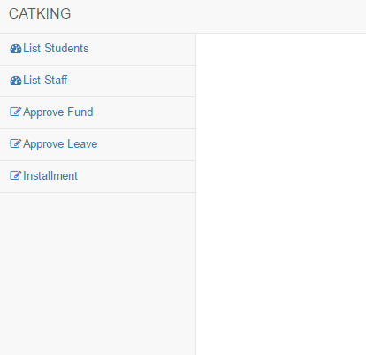

**2Branch Manager**

It will help the branch managers monitor and control

The functioning of their re-spective branch. in this module cover the following step.

-List of Student

-Add Student

-Manage Leave

-Add Vacancy

-Instalment

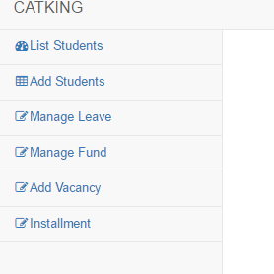

**3HR Management.**

It will help HRs to manage recruitment. in this module cover the following step.

-List Staff

-List Student

-Add Staff

-Manage Leave

-Approve Leave

-Manage Vacancy

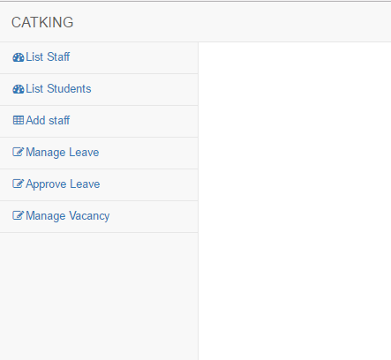

**3)Staff.**

It will help the staﬀ members manage their leave and schedule. in this module cover the following step.

**-**Manage Leave

-weekly Schedule

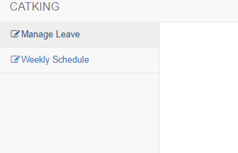

1. **Conclusion**

Business Monitoring Software(BMS) has been successfully implemented. This software will help in automatic on-line functioning of the organization CatKing. This has helped reduce the cumbersome manual tasks thus reducing the work overload on the employees. The top management can now view all the student data across all the branches, approves leaves and allocate funds, notify defaulters about late payment of fess through automatic mailing system. They can also view summary and analysis of finance in the form of bar graphs and charts. This system will help the branch managers in managing the functioning of their respective branch. This will help save a lot of time and improve coordination between various branches. Branch managers can handle student data of their respective branch. They can also apply for leave and request for funds. HR can handle employee recruitment through this system according to the vacancies which are updated by the branch manager. Staﬀ can also easily access their weekly schedules and apply for leaves and check the status of their leaves. Thus this system helps to automate a lot of manual tasks and ease thne functioning of the organzation.

.

**References**

(1) Top 5 benefits of implementing erp software,” http://www.workwisellc.com/ 5-benefits-implementing-erp-software/.

(2) S. Rani, “A review of erp implementation in higher education institutions,” *Interna-tional*

*Journal of Advanced Research in Computer Science and Software Engineering*,vol. 6, 2016

(3) P. Soni, “Erp implementation in organization,” http://www.slideshare.net/ PoojaSoni13/project-reporterpimplemetaion-24331857, 2013.

(4) V. Beal, “Erp - enterprise resource planning,” http://www.webopedia.com/TERM/ E/ERP.html.

(5) V. Kumar, “10 characteristics of a good erp system,” http://www.svtuition.org/ 2014/02/10-characteristics-of-good-erp-system.html.

(6) T. Matys, “An erp overview: Business functions and business processes,” http:// www.slideshare.net/tmatys/business-functions-business-functions-in-erp